EXP-4
String Handling Using Raptor
Aim
To design a flowchart using Raptor to display and return the total number of characters present in a given string.
Procedure
1. Open Raptor and create a new flowchart.
2. Design the flowchart steps:
- Input a string from the user
- Store the string in a variable
- Find the length of the string
- Display the total number of characters
3. Add flowchart logic:
- Use Input Symbol to accept the string
- Use Assignment Symbol to calculate character count
Example:
count ← Length(str)
- Use Output Symbol to display the count
4. Execute and validate the flowchart using different string inputs.
Output
Output 1
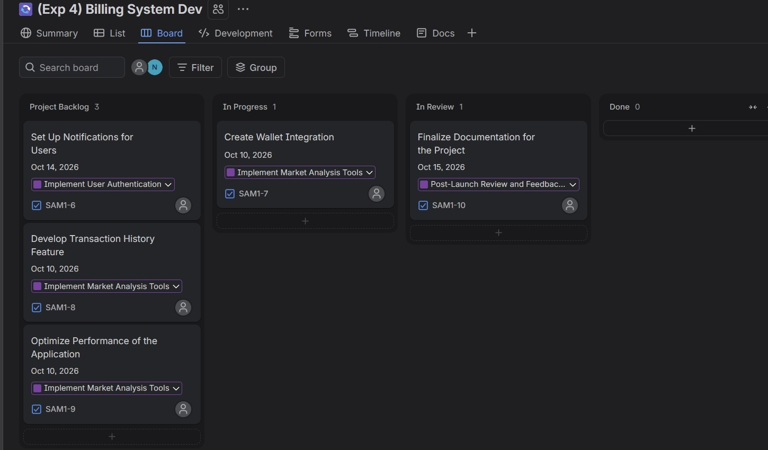
Output 2
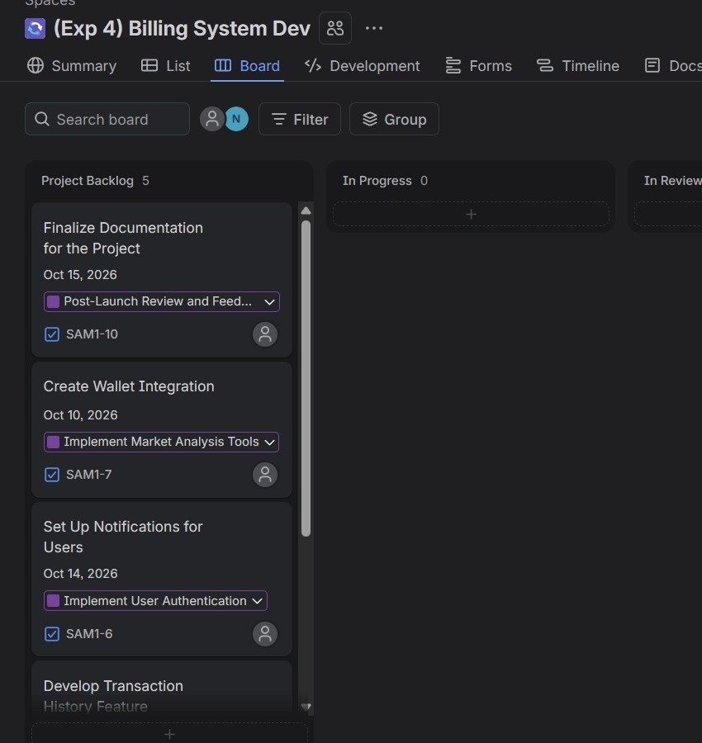
Result
Thus, the flowchart for displaying and returning the total number of characters in a string was created and validated successfully using Raptor.

